**Chess Game**

Bodea Răzvan

Haragâș Alexandru

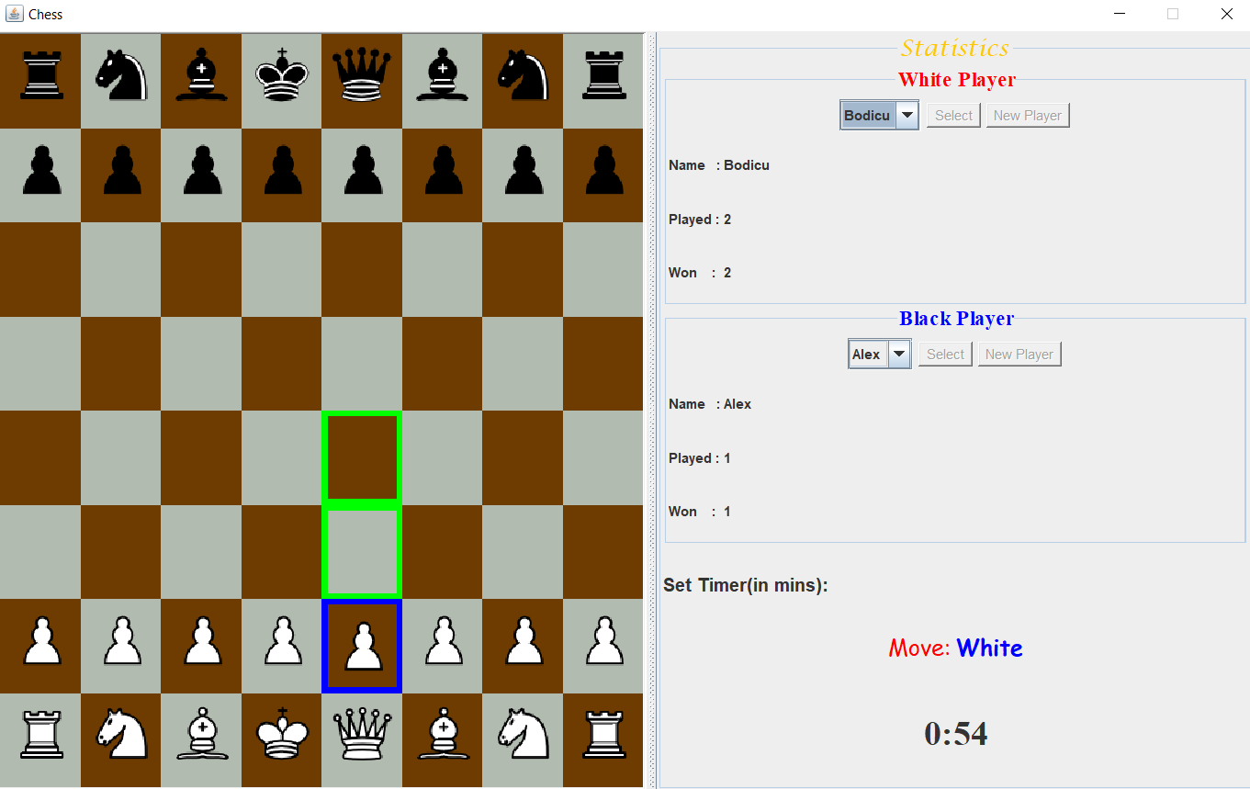

Initial ideas for design:

Classes:

1.Piece: (King, Queen, Bishop, Knight, Rook, Pawn)

->Has a color (Black/White)

->Can move (every piece has a specific movement pattern)

(this method is declared in the piece class and overridden in the specific pieces)

->Can capture/kill

->Can be captured/killed

->Implements Cloneable interface because we need a copy of the piece very often

->King also needs to be checked for attacks

2.Square

->8x8 squares for a full chess board

->can have a piece/no piece(null)

->can be highlighted (red for check, blue for selected, green for possible move)

->the border colors can be reset to default

3.Player

->Stored in a file (.dat type needed)

->Has a turn and time for turn

->Plays with a color

->Selected at the start of the game

->Has a match history

4.Timer

->Keeps track of player turns

->If time runs out the turn is ended

->Can be set (default 60 seconds per player a turn)

->Can be reset

5.Game (Main)

->Keeps track of the turns

->Keeps track of the moves

->Most of the front end is done here (Board declaration, Click listeners, User interface)

->Has extra functions to check the king state and moves (check, check mate, the necessity to block a check or move the king to another spot)

->Calculates result (Win, Loss, Draw)

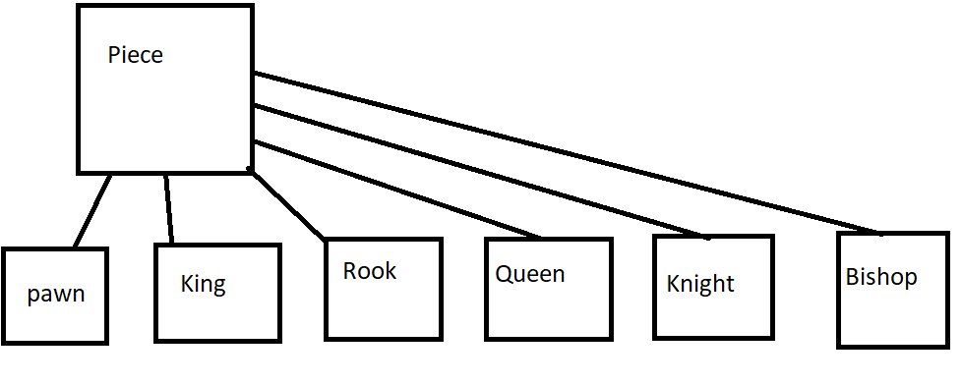

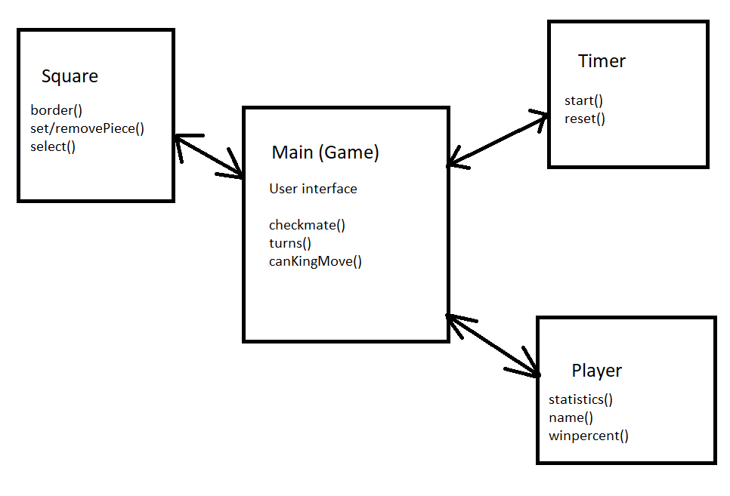

Bibliography:

Stack overflow (help for timer): [multithreading - Java StopWatch in ChessGame - Stack Overflow](https://stackoverflow.com/questions/37059672/java-stopwatch-in-chessgame)

GeeksForGeeks (basic chess game logic): [Design a Chess Game - GeeksforGeeks](https://www.geeksforgeeks.org/design-a-chess-game/)

Tutorials for chess game : [Intermediate Java - Program-Your-Own-Chess Tutorial - YouTube](https://www.youtube.com/watch?v=yyhNBV_5ayM&ab_channel=Mr.Soderquist)

Reading and writing from/to files (used for players): [Reading and Writing Files in Java (stackabuse.com)](https://stackabuse.com/reading-and-writing-files-in-java/)